**Experiment 3.1**

**Student Name: Gaurav Kumar                                     UID: 22MCC20177**

**Branch: CC-DEVOPS Section/Group : 1/B**

**Semester: 1                                                                    Date of Performance: 08/12/2022**

**Subject Name : Python Programming                         Subject Code: 22CAH645**

1. **Perform different statistics operations on dataset taken from kaggle.(Heart Disease Dataset)**

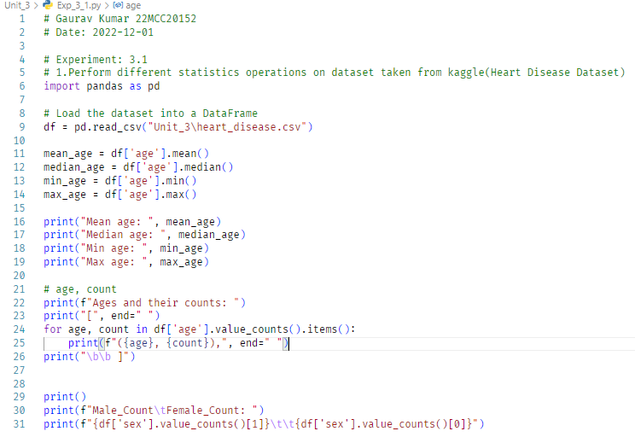

**Output (screenshots):**

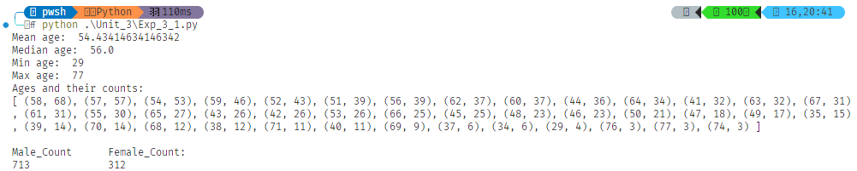

**4) Learning outcomes (What I have learnt): Times new roman 12 size**

**1. Learn about pandas library**

**2. Learn about reading csv**

**3. Learn about getting data fro csv**

**Evaluation Grid:**

|  |  |  |  |
| --- | --- | --- | --- |
| Sr. No. | Parameters | Marks Obtained | Maximum Marks |
| 1. | Demonstration and Performance  (Quiz) |  | 22 |
| 2. | Worksheet |  | 8 |